The global energy storage systems market is rapidly growing due to increased demand in numerous sectors like transportation, IT, and finance. The need for clean and renewable energy will likely propel the market further as it is an affordable and efficient energy resource alternative to fossil fuel. However, capital investment and maintenance restrain the battery energy storage systems market. On the flip side, the increase in the electric vehicle sector and recent investments in the power infrastructure network are expected to create tremendous opportunities in the coming years. The global energy storage systems market was valued at 211.24 GW in 2021 (Figure 1) and is increasing at a CAGR of 11% from 2022 to 2030 [1]. The global market generated $188.5 billion in 2020 and is rising at a CAGR of 8.3%, estimated to reach $435.4 billion by 2030 [2].

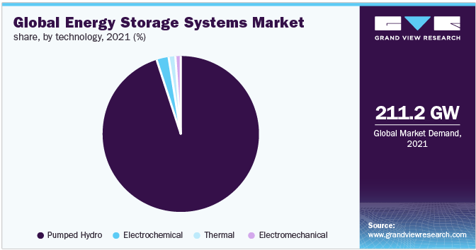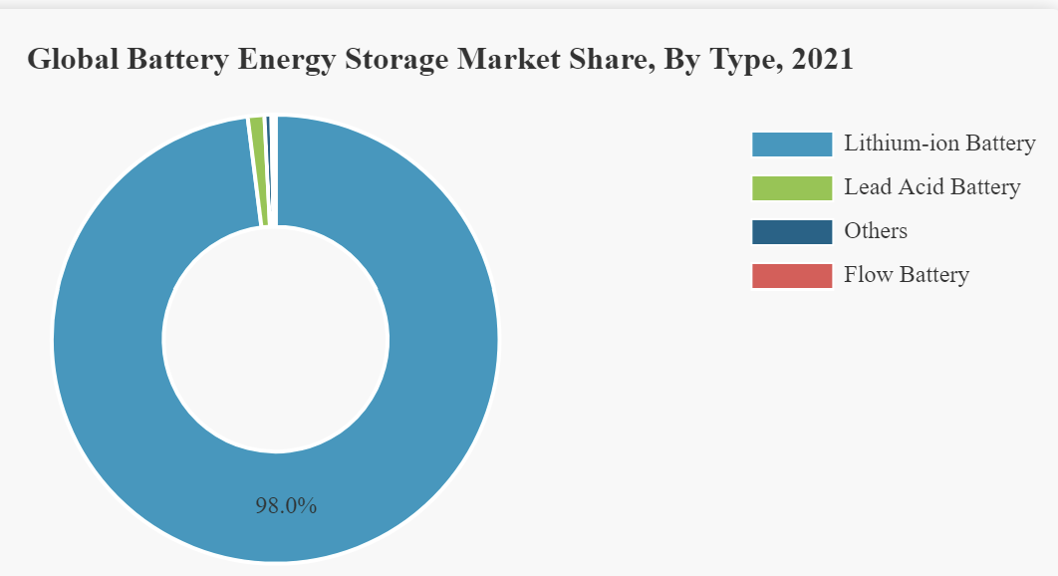

Energy is essential for everyday activities across numerous different sectors to function. The increasing demand for electricity and the rising ozone-harming greenhouse discharges has led organizations to adopt low carbon emission frameworks while generating energy. Battery Energy Storage systems (BEES) are one such sector that significantly creates innovations that use battery chemistries to store energy to serve the demand. The battery market is segmented based on the type, lithium-ion batteries, lead-acid batteries, nickel batteries, flow batteries, and others (Figure 2). The battery energy storage market size is valued at $9.21 billion in 2021 and is estimated to grow from $10.88 billion in 2022 to $31.20 billion by 2029, exhibiting a CAGR of 16.3% [3]. Based on geographical locations the battery market is categorized across four main regions, Asia Pacific, Europe, North America, and the Rest of the world. The Asia Pacific is leading the market with an estimated $4.16 billion in 2021 (Figure 3) and has the potential to share the major share in terms of volume and value in the coming years.

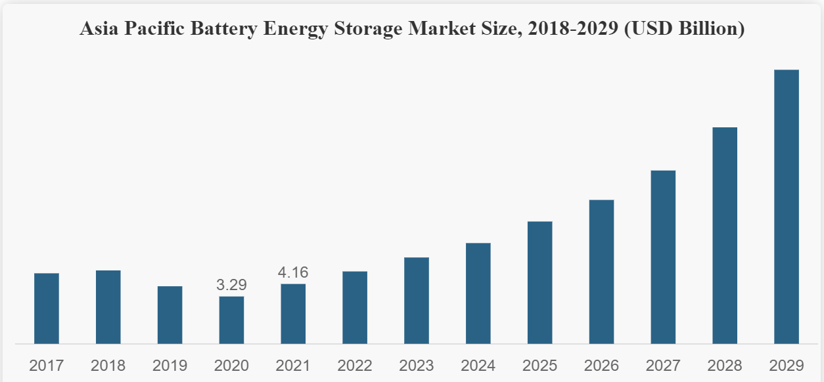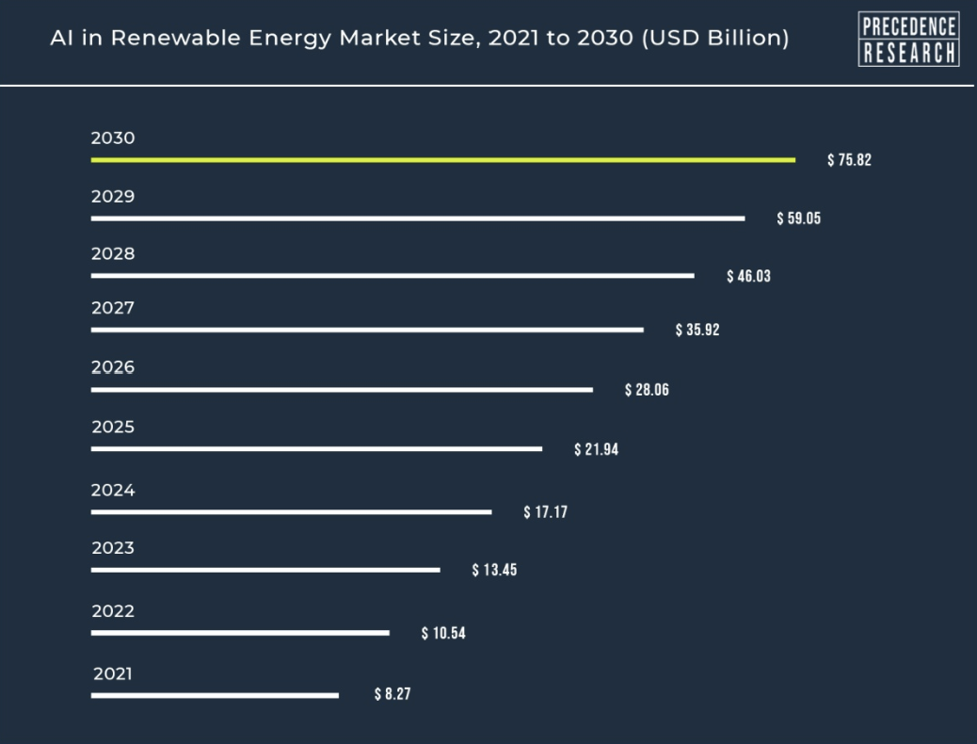

As Asia Pacific, America, and Europe dominate the battery market, Artificial Intelligence (AI) has emerged as a promising tool to accelerate the rate of innovation. AI has been experimented with overcoming long evaluation periods, optimizing battery structure, and faster, more effective materials discovery [4]. Due to the increasing use of portable electronics, the consumer electronics industry is expected to proliferate in the coming years. AI in the renewable energy sector was valued at $8.67 billion in 2021 and is estimated to reach $75.82 billion by 2030, exhibiting a CAGR of 27.9% [5]. With AI playing a key role in the renewable energy sector the battery market will have to increase its focus on launching intelligent battery systems to improve battery performance and achieve a better Return on Investment [6]. Some global players in the battery market include BYD Company Ltd, Kokam, LG Chem, NGK Insulators Ltd, and Samsung SDI Co Ltd. These are some of the major companies competing in the battery market for Energy Storage Systems (ESS) [7].

References:

[1] [Energy Storage Systems Market Size Report, 2030 (grandviewresearch.com)](https://www.grandviewresearch.com/industry-analysis/energy-storage-systems-market)

[2] [Energy Storage Systems Market to Reach $435.4 Bn, Globally, by 2030 at 8.3% CAGR: Allied Market Research (prnewswire.com)](https://www.prnewswire.com/news-releases/energy-storage-systems-market-to-reach-435-4-bn-globally-by-2030-at-8-3-cagr-allied-market-research-301534152.html)

[3] [Battery Energy Storage Market Size, Share | Growth [2022-2029] (fortunebusinessinsights.com)](https://www.fortunebusinessinsights.com/industry-reports/battery-energy-storage-market-100489)

[4] [Next-Generation Batteries Will Be Brought to You by AI | Electronic Design](https://www.electronicdesign.com/power-management/whitepaper/21177573/addionics-nextgeneration-batteries-will-be-brought-to-you-by-ai)

[5] [AI in Renewable Energy Market Size to Surpass US$ 75.82 Bn (globenewswire.com)](https://www.globenewswire.com/en/news-release/2022/05/01/2433085/0/en/AI-in-Renewable-Energy-Market-Size-to-Surpass-US-75-82-Bn-by-2030.html)

[6] [AI in Battery Management Market | Trends, Segmentation, Key Players, 2030 (psmarketresearch.com)](https://www.psmarketresearch.com/market-analysis/ai-in-battery-management-market)

[7] [Battery Market for Energy Storage Systems (ESS) 2019-2023 | Evolving Opportunities with Kokam and LG Chem | Technavio | Business Wire](https://www.businesswire.com/news/home/20190912005581/en/Battery-Market-for-Energy-Storage-Systems-ESS-2019-2023-Evolving-Opportunities-with-Kokam-and-LG-Chem-Technavio)